Preparation of an Extended Summary for
IPEC-Niigata 2018

Track number: Please indicate your track number here.
Do not indicate authors' names!

Abstract-Basic guidelines for the preparation of an extended summary for IPEC-Niigata 2018 are presented. This document is itself an example of the layout and can be used as a template if you want. The format of the extended summary is free except what is described in the first section of this document.

Introduction
An extended summary describing work not previously published or presented must be electronically submitted in PDF file through the conference website no later than Oct 16, 2017. The extended summary should be up to 4 pages long, two-column, single-space on either A4 or 8.5 by 11 inch (letter size) format with supporting figures, tables and references, headed by title of paper and choice of topic category. Please do not indicate authors' names.
The font size should be 24pt for title, 9pt for abstract, figure/table captions and references, and 10pt for main text. Please use “Times New Roman”, “Symbol” or compatible fonts. Do not use 2-byte characters to avoid the troubles in printing. Table I and Fig. 1 provide samples. List one reference per reference number. Number reference citations consecutively in square brackets [1]. Number equations consecutively with numbers in parentheses flush with the right margin, as in (1).
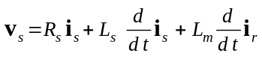 (1)
A PDF file of the extended summary should be submitted. The submitted extended summary will be reviewed via a peer review process in order to ensure the highest technical quality of the conference. The extended summary should clearly define the salient concepts and novel features of the work. Be sure to mention past or previous works to distinguish your originality from them. For additional information not included in these instructions, please contact IPEC-Niigata 2018 secretariat at ipec2018@jtbcom.co.jp.

TABLE I
Fundamental Physical Constants
Symbol | Meaning | Value
μ₀ | Magnetic constant | 4π x 10⁻⁷ NA⁻²
ε₀ | Electric constant | 8.854 x 10⁻¹² Fm⁻¹

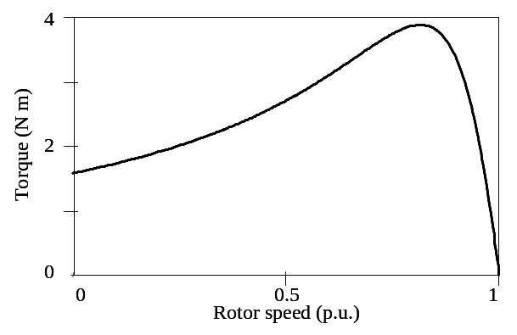
Fig. 1. Torque-speed characteristic of a three-phase induction motor.

Information
The Industry Applications Society of the Institute of Electrical Engineers of Japan is pleased to announce that the International Power Electronics Conference -ECCE Asia- (IPEC-Niigata 2018) will meet May 20th through 24th, 2018 at TOKI MESSE Niigata Convention Center in Niigata, Japan. This international conference is technically co-sponsored by IEEE Industry Applications Society and IEEE Power Electronics Society. As the seventh IPEC since 1983, the Hiroshima Conference will provide a unique opportunity for engineers, researchers and academicians to assemble in a historical city in Hiroshima and exchange the latest information on power electronics, motor drives, motion control and related subjects. All papers presented will be published in the IEEE Xplore.

References
- M. Young, “The PWM strategy on DC-DC converter,” IEEJ Journal of Industry Applications, vol. 28, no. 15, pp. 123-129, 1989.
- G. Eason, B. Noble, and I. N. Sneddon, “On certain integrals of Lipschitz-Hankel type involving products of Bessel functions,” IEEE Trans. on Power Electronics, vol. 247, no. 8, pp. 529-551, 1995.
- J. Clerk Maxwell, “A treatise on electricity and magnetism,” IEEE Trans. on Industry Applications, vol. 589, no. 2, pp. 68-73, 2010.

